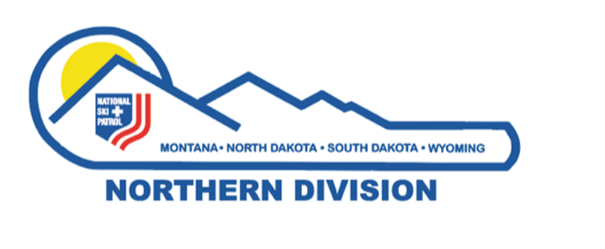
Northern Division - National Ski Patrol
Dwight Chambers Rising Star Award

Established: May 2015, in honor of Dwight Chambers’ outstanding service to the Northern Division, NSP, and for his untiring dedication, commitment, and leadership as an example to others, especially young patrollers.

Purpose: Honor a current member in good standing of the Northern Division, National Ski Patrol, 35 years of age or younger as of January 1 of the year of nomination, who has exhibited the qualities of dedication, commitment, and leadership in his or her local patrol, region, and/or division.
Each year one nominee who meets the qualifications will be selected by the Northern Division Awards Advisor/Review Board to receive the award.

Qualifications of Nominee:
- Must be a current member in good standing with National Ski Patrol. National Ski Patrol Member in Good standing is a patroller who demonstrates above average level of skills and knowledge in emergency response. Patroller displays integrity, maturity, and good judgment. Patroller has a good attitude towards ski patrolling. Patroller is cooperative, constructive and demonstrates a willingness to accept responsibilities and a desire to improve skills and knowledge. Patroller abides by rules set forth by National/Division Administration to maintain National Ski Patrol status as a patroller. Patroller is current paying National and Division dues.
- Have been an active patroller for a minimum of three years.
- Must demonstrate outstanding qualities of dedication, commitment, and leadership to his/her local patrol, region, and/or division.
- Must be sponsored by his/her local Patrol Director, or representative.

Sponsors of Nominee:
- The Patrol Director/Representative of the nominee will complete the following form and a one-page letter of recommendation to the Northern Division Awards Advisor by the selected deadline date.
- Note: It is an honor for all nominees to be nominated for this prestigious award. All nominations will be considered deserving if they meet the qualifications. It is the sponsor’s responsibility to write an application and recommendation letter with a strong argument for why the nominee deserves the award. The Northern Division Awards Review Board’s job is to review all applications and select the strongest nominee for the award. The Dwight Chambers Rising Star Award is based on merit as indicated by the nomination the sponsor has submitted, and it is never to become a popularity contest.
- Your signature as sponsor attests to the fact that all information you have provided is correct.

Return Nomination form and letter of recommendation to Colleen Finch, Northern Division Awards Advisor.
Email: finchski200@gmail.com
1318 24th Ave SW
Great Falls, MT 59404

Submission Deadline: July 15th, 2024

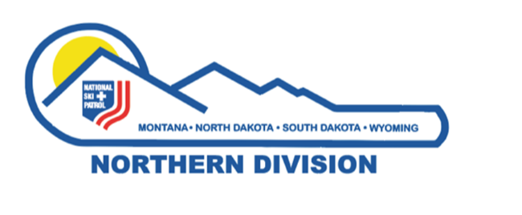
Northern Division - National Ski Patrol
Dwight Chambers Rising Star Award

Nominee’s Name:

NSP #: _________________ Nominee’s Registered Patrol:

Nominee’s Address:

The form has a simple format to enable sponsors to complete. If you have questions or concerns, contact the Northern Division Awards Advisor
Column A: Verify the criteria has been met.
Column B: If known complete (if unknown the Northern Division Awards Advisor may obtain or request additional information from the Northern Division Registrar)
Column C: To be completed by the Awards Advisor/Northern Division Review Board

Nominee | A  Y(yes) | B  Years and date(s)/Additional Information  (Complete if known) | C  Awards Committee Column
1. Current member-good
standing
2. Active Member 3+
years
3. Discipline(s) Current
Instructor of:

4. Dedication to NSP (describe):

5. Commitment to patrolling (list examples):

6. Leadership (list positions and examples):

7. Recommendation letter  from sponsor attached |  | Past acknowledgements, special trainings, other Division NSP attributes to the Division, personal knowledge. Sponsor comments
Name of sponsor:

Address of Sponsor:

Current Position of Sponsor in Northern Division:

Signature of Northern Division Awards Advisor ____________________________________ date ______________

Dwight Chambers 1945-2014

Beginning in the 2014/2015 season, the lifts will run much quieter and the powder will be left undisturbed in the glades as Dwight Chambers left us to join God’s Ski Patrol. In March 2013, Dwight suffered a skiing accident that paralyzed him from the chest down. He persevered through seven months of hospitalization and rehab to return home and begin his life anew despite his disability. In May 2014, we lost a friend, a patroller, and a gentleman. Dwight G. Chambers left us on May 30, 2014, at VA Puget Sound Medical Center in Seattle, Washington.
Dwight was born on March 22, 1945, in Phoenix, Arizona.
Dwight grew up on the family farm and graduated from Glendale Union High School in 1963.
While attending college, Dwight was a bull rider and roper on the college rodeo circuit.
He financed his college education by working summers as a Smokejumper based out of the Missoula Jumper Base.
In September of 1968 Dwight was accepted into officer candidate school for the US Marine Corps at Quantico, Virginia. He proudly served for three years in the Marine Corps, attaining his pilot’s license, and graduating to flying the T-38 Talon and A-4 Skyhawk.
Dwight’s first forestry job in Libby began his 40-year career with the US Forest Service and his love affair with Montana. He later served in Sula, Great Falls, Missoula, Superior and 19 years at the Supervisor’s Office in Helena, Montana. Dwight always enjoyed getting back to his Smokejumper roots on summer fires. The highlight of his summer was buzzing through the gray smoke of a wildfire as Air Attack Coordinator. Dwight was a man of few words, and he seldom asked anyone for assistance. Yet he spent his life volunteering his time. He served in the National Ski Patrol organization most every place he worked during his Forest Service career, receiving his 30-year service recognition award in 2013.
Dwight patrolled at Turner Mountain in Libby, MT from 1971 through 1975; at Lost Trail Pass near Salmon, ID from 1975 through 1978, at Showdown near Neihart, MT from 1978 through 1981, at Missoula, MT SnowBowl in 1981 through 1984 (with a year off for his master’s degree in Michigan) and at Great Divide near Helena, MT from about 1993 through his accident in 2013. He couldn’t patrol at Lookout Pass, Idaho/MT border when he was the Ranger at Superior. Funny thing is, the Forest Service thought it would be a conflict of interest since the ski area was on Forest Service land.
Dwight loved his family, his country, his chunk of paradise in the Swan Valley, Civil War history, classical music (especially the brass parts!), old guns, Lay’s classic potato chips, and he never gave up on the Dallas Cowboys.
Dwight is survived by his wife Jo Ann, sons Beau (Jenna) of Maple Valley, WA; Cameron of Seattle, WA; daughter Mariah of Camarillo, CA; grandchildren Hudson and Beckett Chambers, brother John Chambers (Marge), sister Cheryl Chambers and many in-laws, cousins, nieces and nephews.
The Great Divide and Northern Division patrollers dearly miss Dwight and the space he left will only grow as we realize how much we miss his quick wit, his sage advice, his stories from a wonderful and adventurous life, and his ability to be a solid, stabilizing influence. Great conditions will return this season, as they always do, and as surely as the snow quietly falls in the glades our thoughts will return to memories of Dwight and his great sense of humor. As his favorite T-Shirt said, “Handicapped – You can’t beat the parking”

