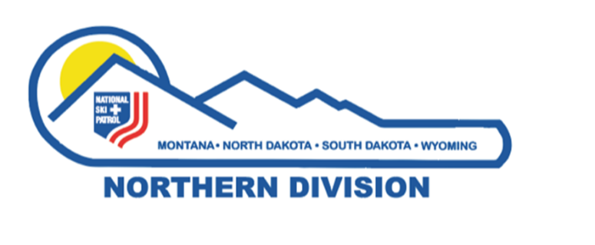
Northern Division - National Ski Patrol
Mark Behan Outstanding Instructor Award

Established: July 2008, in honor of Mark Behan’s Outstanding Service to Northern Division

Purpose: Honor a Current Member in good standing of the Northern Division National Ski Patrol for outstanding service as an instructor in Northern Division
Each year one nominee who meets the qualifications will be selected by the Northern Division Awards Advisor/Review Board to receive the award.

Qualifications of Nominee:
- Must be a current member in good standing with the Northern Division and the National Ski Patrol. A Member in Good standing is a patroller who demonstrates above average level of skills and knowledge in emergency response. Patroller displays integrity, maturity, and good judgment. Patroller has a good attitude towards ski patrolling. Patroller is cooperative, constructive and demonstrates a willingness to accept responsibilities and a desire to improve skills and knowledge. Patroller abides by rules set forth by National/Division Administration to maintain National Ski Patrol status as a patroller (up to date credentials required by an instructor). Patroller is current paying National and Division dues.
- Must have a National Appointment. (National Number)
- Has been an active patroller for a minimum of 25 years.
- Must be a current or previous Instructor of a Discipline
- Must be an instructor in a discipline for a minimum of 2 years.
- Must have been outstanding while holding that position and continue to be an asset in Northern Division
- Must be sponsored by a qualified nominee who submits the nomination form and a letter of recommendation.

Sponsors of Nominee:
It will be the responsibility of each Division Discipline Supervisor to nominate at least one person every year. The Division Director, Assistant Director, Regional Directors, and any past recipients of the Mark Behan Award may also make a nomination- but they cannot nominate themselves.
Sponsors will complete and send the following form and a one-page letter of recommendation to the Northern Division Awards Advisor by the selected deadline date.
- Note: It is an honor for all nominees to be nominated for this prestigious award. All nominations will be considered deserving if they meet the qualifications. The Northern Division Awards Review Board’s job is to see that one person is selected out of the many deserving nominations received. The Mark Behan Award is based on merit the sponsor has submitted and it is never to become a popularity contest.
- Your signature as sponsor attests to the fact that all information you have provided is correct.

Return Nomination form and letter of recommendation to Colleen Finch, (Northern Division Awards Advisor)
email: finchski200@gmail.com
1318 24th Ave SW
Great Falls, MT 59404

Deadline: July 15th, 2024

Those eligible to sponsor nominees for this award include: Division Director, Assistant Division Director, Region Directors, Division OEC Supervisor, Division OET Supervisor, Division Avalanche Supervisor, Division MTR Supervisor, Division ID Supervisor, Division Nordic Supervisor as well as past recipients of the Mark Behan Award.
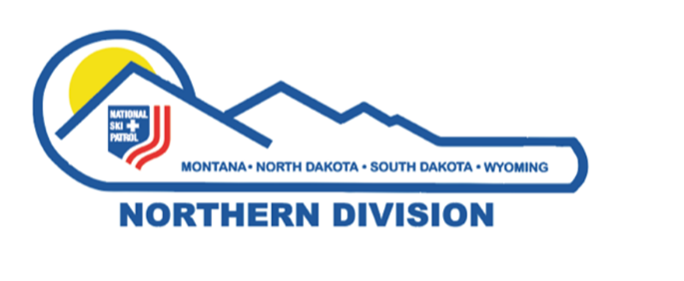
Northern Division - National Ski Patrol
Mark Behan Outstanding Instructor Award

Nominee’s Name:

NSP # __________________ Alumni ⁭ Active ⁭ Nominee’s Registered Patrol:

Nominee’s Address: _________________________
The form has a simple format to enable sponsors to complete. If you have questions or concerns, contact the Northern Division Awards Advisor
Column A: Verify the criteria has been met.
Column B: If known complete (if unknown the Northern Division Awards Advisor may obtain or request additional information from the Northern Division Registrar)
Column C: To be completed by the Awards Advisor/Northern Division Review Board

Nominee | A  Y(yes) | B  Years and dates/Additional Information  (Complete if known) | C  Awards Committee Column
1. Current member-good
standing
2. National Appointment |  | National Appointment Number:
3. Active Member 25
years
4a. Discipline(s) Current  Instructor of:  (Note if Instructor  Trainer or Division/  Regional Advisor) |  | List:
4b. Discipline(s) Previous  Instructor of:  (Note if Instructor  Trainer or Division/  Regional Advisor) |  | List:
5. Instructor Minimum  years 2 |  | Number of years:
6. Outstanding /Asset
7. Recommendation letter  from sponsor attached |  | Past acknowledgements, special trainings, other Division NSP attributes to the Division, personal knowledge. Sponsor comments
Name of Sponsor:

Address of Sponsor:

Position of Sponsor in Northern Division or year Sponsor received the Mark Behan Award: _________________

Signature of Northern Division Awards Advisor ____________________________________ date ______________
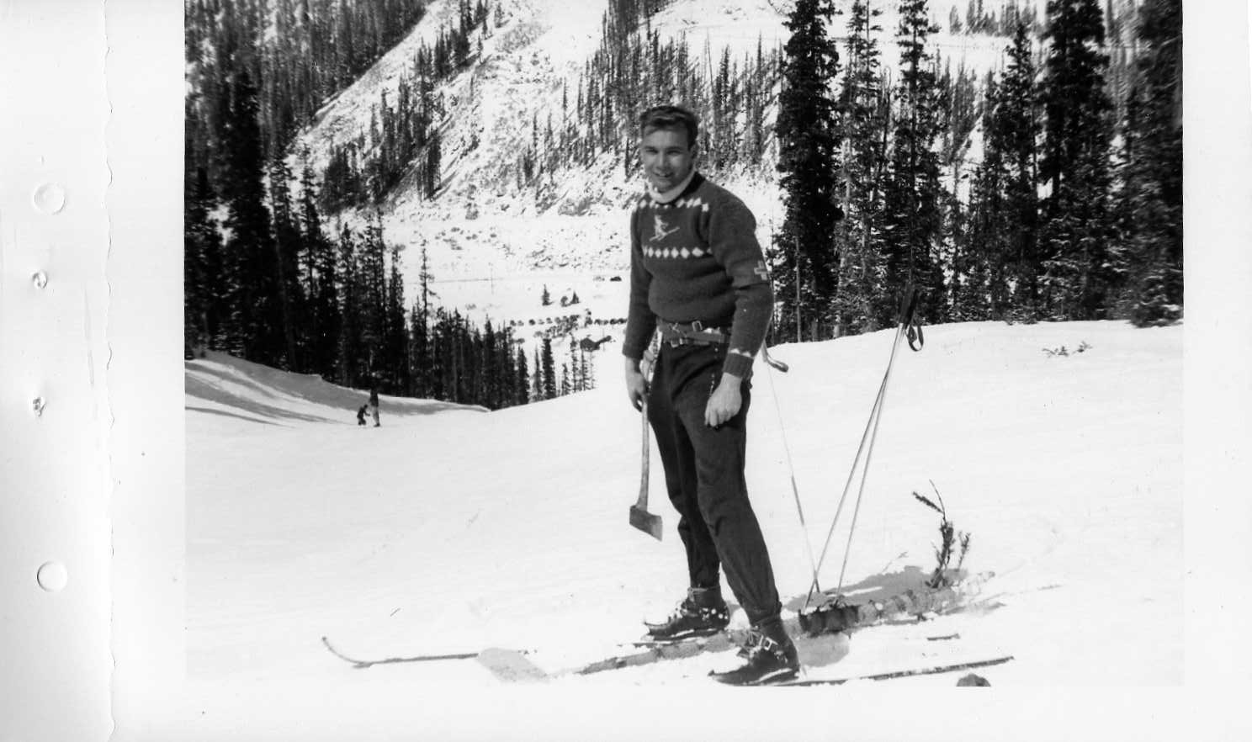
History of the Mark Behan Outstanding Instructor Award
The Mark Behan Outstanding Instructor Award is the most prestigious award that the Northern Division can bestow upon a Patroller. This award was created in 2008 to honor the memory of a man who dedicated much of his life to teaching and patrolling.
First, let me tell you a bit about the truly amazing patroller and educator this Award is named after, with thanks to Steve Thompson, Northern Division Historian, who provided much of this history. Mark Behan’s 56 years of patrolling began in 1952 while he was an undergraduate student in Colorado, at Loveland and Arapaho Basin. He continued to patrol through his undergrad and grad school years. This included moving to Wyoming, where he created a patrol in Laramie, and then on to Washington. After graduating, Mark landed in Missoula, Montana in 1960 as a Professor of Botany at the University of Montana.
Once settled, Mark quickly rose through the NSP ranks: From Region SS&T Advisor (1965), Region Chairman (1965-67), Assistant Northern Division Director (1967-1968), Northern Division Director (1967-68), to 1st Assistant National Director (1976-81).
Because of his ongoing and outstanding contributions to his Patrol, the Northern Division and National NSP, Mark was awarded the Minnie Dole Award in 1982. Mark Behan was only the 6th person to receive this highly coveted award since its inception in 1969. Only 28 Minnie Dole Awards have ever been given. From the NSP website - The Minnie Dole Award is one of NSP’s most rarely given awards, which “recognizes those exceptional few patrollers who, over the years, have closely exemplified the long-term dedication, devotion, and self-sacrifice of the founder of the NSP, Charles Minot ‘Minnie’ Dole.”
Mark was a leader and teacher in many areas of his life. His main passion within the NSP was Avalanche Education (this interest may have stemmed from being caught in an avalanche in his early patrol years). He was an Avalanche 1 and Avalanche 2 instructor, an Avalanche Instructor Trainer and a professional member of the American Avalanche Association. One of his many contributions to avalanche education was a home study guide he created for the Avy 2 course in 1999, to make the course accessible to everyone in the Northern Division. Mark made his three young sons pass the Avalanche 2 course using his newly minted study guide, before he put it into circulation. This study guide has stood the test of time, with updates and revisions, and has been used well beyond Mark’s death in 2008. All the avalanche instructors in this division are affected directly or indirectly by Mark’s powerful and lasting instruction.
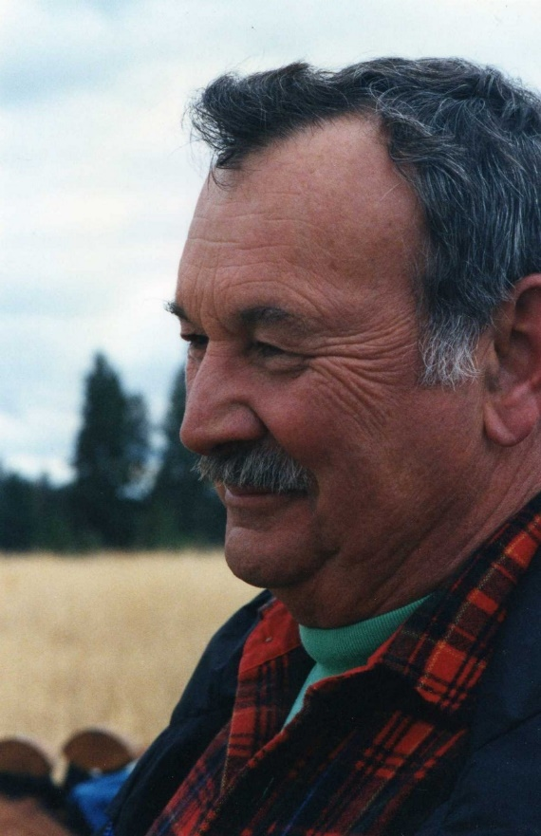
Mark Behan was inducted into the National Ski Patrol Hall of Fame in 2022.
Now that you know a little about Mark Behan, let me tell you about the Award that was created in his honor. This award was created to recognize the long serving and outstanding instructors in the Northern Division. Mark always expected the most of himself and best of his students, so the bar was raised high when creating the criteria to even be nominated for this award. The criteria include:
- Must be a current member in good standing with National Ski Patrol.
- Must have a National Appointment. (National Number)
- Have been an active patroller for a minimum of 25 years
- Must be a current or previous Instructor of a Discipline
- Must be an instructor in a discipline for a minimum of 2 years
- Must have been outstanding while holding that position and continue to be an asset in Northern Division
- Must be sponsored by a qualified nominee who submits a letter of recommendation. (Those eligible to sponsor nominees for this award are: Division Director, Assistant Division Director, Region Director, Division OEC Supervisor, Division OET Supervisor, Division Avalanche Supervisor, Division MTR Supervisor, Division ID Supervisor, Division Nordic Supervisor or a past recipient of the Mark Behan Award)

