Hall of Fame Highlights
The National Ski Patrol Hall of Fame was created in 2013, in conjunction with the 75th NSP Anniversary Celebration. The NSP HOF inductees are the Superstars, the Legends, and the Leaders of our organization who have dedicated so much to create, develop, and improve the NSP. This prestigious award is presented to Patrollers who have had a positive and lasting impact on the NSP.
The Northern Division currently has six patrollers who have been inducted into the NSP HOF. Here are a few highlights of each of these patrollers.

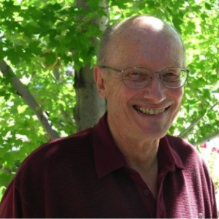
Class of 2013
Warren Bowman was in the inaugural Hall of Fame Class of 2013. Bowman authored the first emergency care manual specific to the nonurban rescuer and oversaw four versions of Outdoor Emergency Care.
He was a founder and president of the Wilderness Medical Society and medical director of the National Association of Search and Rescue (NASAR). A two-time recipient of the NSP Outstanding Administrative Patroller Award (1978 and 1989), Bowman also received the prestigious Minnie Dole Award (1990).

Class of 2019
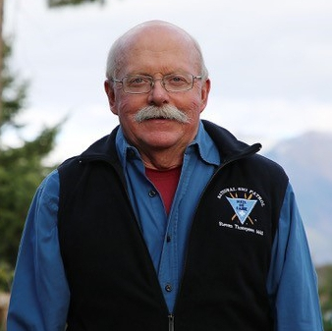
Steve Thompson joined the NSP in 1960. Steve has accomplished so much in his 60+ years as a Patroller, instructor, mentor, and leader.
In his early years, while stationed in Europe he was instrumental in starting three new Patrols. He was also the Regional Director for Southern Europe.
Once back in the States his energy and enthusiasm for the NSP continued, from the local to the National level. He filled many roles, including Instructor in OEC IT, ID IT, MTR and AVY 2 IT, Section and Regional Director, Division Avalanche Supervisor, and now the Division Historian. I am sure I am missing a few highlights since Steve is always up to something!
Steve has earned a National Appointment #4668 in 1975, a Distinguished Service Award, two Yellow Merit Stars and a Purple Merit Star.

Class of 2020
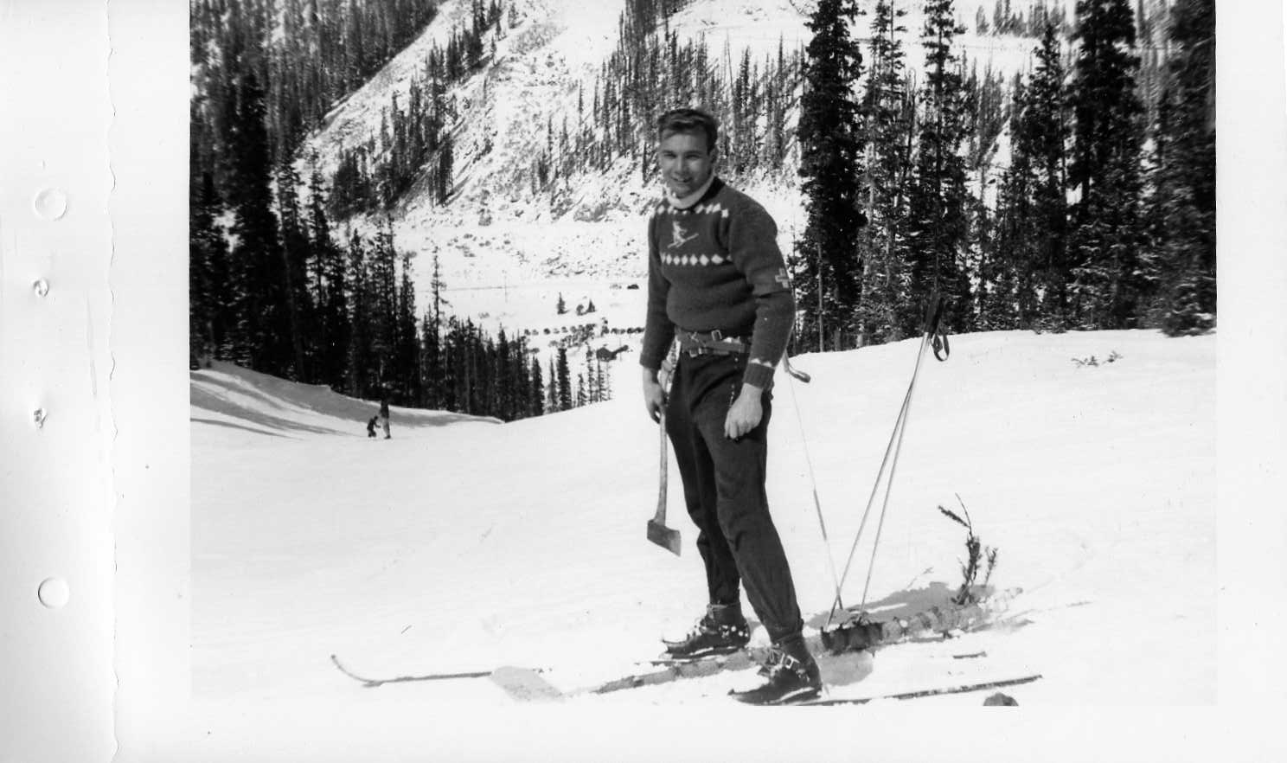
Mark Behan began his patrolling career at Loveland Ski Area in 1951. From then until his death in 2008, Mark either joined a ski patrol or organized one wherever he was living. He held nearly every position possible in NSP – from basic patroller to Division Director, to 1st Assistant National Director. Behan earned the prestigious Minnie Dole Award in 2003.
Marks true passions were Education and Avalanche. He guided and developed Avalanche training at the local, Division and National levels.
The Northern Division Mark Behan Outstanding Instructor Award was created in 2008 to recognize and honor his dedication to teaching and the NSP.

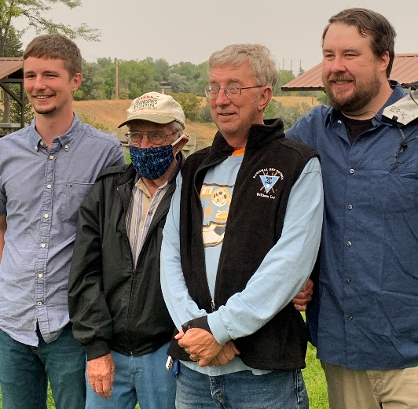
Bill Lay joined the NSP in 1977 and has since dedicated much of his time and energy to his patrol, the Northern Division and the NSP. His leadership roles include Instructor in OEC IT and AVY IT, Patrol Representative twice, Region and Division First Aid Advisor, and currently the Northern Division Registration Advisor.
Bill was chosen to Patrol the 1988 Winter Olympic Games in Calgary, Canada.
He has earned a National Appointment #6688, a Meritorious Service Award, Seven Yellow Merit Stars and a Gold Merit Star as the 2020 National winner of the NSP Outstanding Administrative Patroller Award.

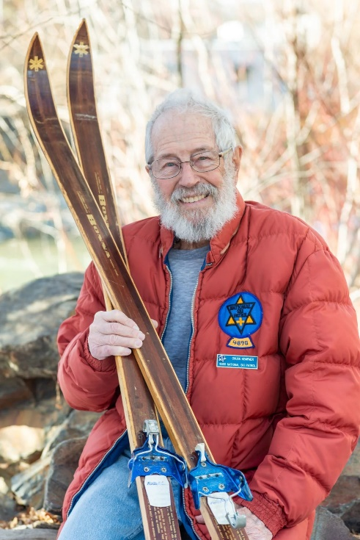
Class of 2021
Charles (Chuck) Kempner joined the NSP in 1969 and quickly made a name for himself. He was instrumental in the founding of two Nordic Patrols in the Intermountain Division. He has been Patrol representative for 3 different patrols. He has held multiple Section, Region, Division and National leadership positions. He was a member of the 1980 US Olympic Nordic Ski Patrol in Lake Placid, NY. He was an instructor for 42 years in MTR, AVY 1 and 2, and OEC.

Class of 2023
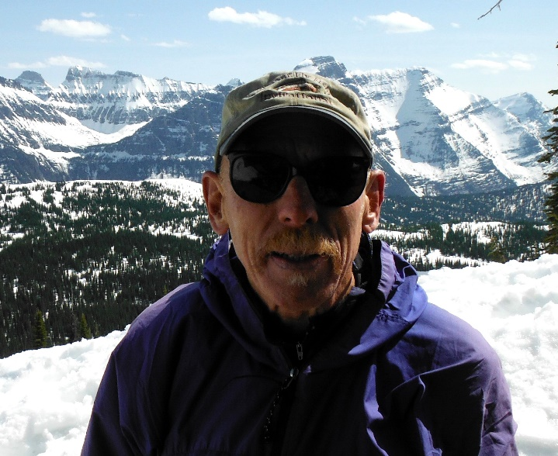
Rusty Wells joined the NSP in 1983. In the last 40+ years Rusty has done just about everything in the NSP. There is not enough room to list it all, but here are a few highlights: He is an instructor and mentor in MTR 1&2, Avy 1&2, Nordic, OEC and Instructor Development. He has been a Patrol Representative, MTR Supervisor, Nordic Supervisor and Region Director as well as serving on multiple National committees. He was part of the organizing committee for the NSP National Meeting in Kalispell, MT in 2000. Rusty worked out an agreement with the Flathead County Search and Rescue for joint support on lost/ missing persons in the Flathead area. Rusty coordinated an agreement with the National Park Service personnel in searches for lost/injured persons in and around Glacier National Park. He was involved in the re-writing of the NSP Ski Patroller manual for the Mountain Travel & Rescue Manual 2nd edition that was published in 2012.
Rusty has been on multiple backcountry searches and rescues, earning Green Merit Stars for two incidents. He has also earned 4 Yellow Merit Stars, National Appointment #8602 in 1997 and he received the Northern Division Mark Behan Award in 2014.

