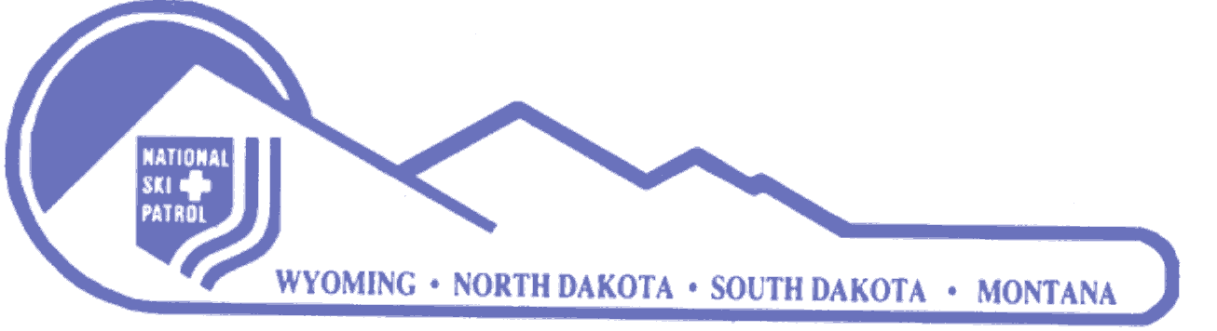

Members of the Northern Division,

National Ski Patrol

The “Northern Division Patriot Award” was established in 2014. The purpose is to acknowledge our men and women of the United States Military services who are also members of the National Ski Patrol System. A candidate for this award must meet all of the following requirements:

1. Must be currently an active or alumni member, in good standing, of the National Ski Patrol and the Northern Division.
2. Must be, or have been, a member of the armed forces of the United States (Air Force, Army, Coast Guard, Marine Corps, Navy, Space Force, National Guard or Reserve or special services such as Merchant Marine) on active duty for at least 180 cumulative days and have completed basic training.
3. Must be currently in good standing in, or have been honorably discharged from, the armed forces of the United States; official documentation (DD Form 214) of active duty dates and deployments may be required.

This award will consist of a red and blue star with a white cross in the center. The inscriptions will be placed on a pin approximately three-fourths inch in diameter and patch approximately two inches in diameter, to be provided by the Northern Division and appropriately displayed by the recipient. The award certificate will be signed by the Northern Division Director or his/her acting. Applications for this award are available on the Northern Division website. Nominations must be presented only with the nominee’s foreknowledge and approval.

